Journey to Iran:
A Dialogue of Peace

Presented by Cobb & Associates
and Authentic Asia

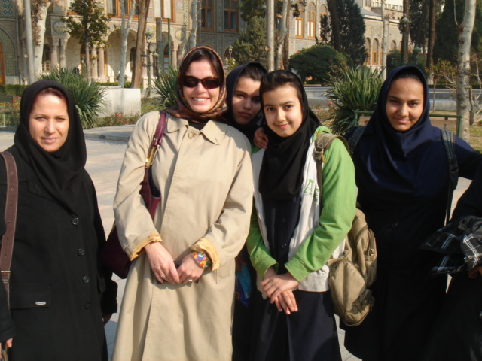

Iran has always been a source of mystery for the intrepid traveler! It has witnessed more than ten thousand years of history and is a land of rich culture and home to several World Heritage Sites. It is a land where the teachings of great mystics, philosophers and poets alike are treasured and will be continued for thousands of years to come.

The country stretches from the tropical shores of the Caspian Sea to the desert and oasis towns of Kavir and Lut and on to the snowcapped Zagros and Elborz Mountains. The beauty and variety of scenery to be found throughout Iran is breathtaking and the thousands of minarets and domes glistening in the sun bear witness to the splendor of Islamic architecture.

In January 2010, I set out on a 10 day private journey through Iran accompanied by a guide and driver. My guide turned out to be one of the best I had ever traveled with. He had obtained his Master’s Degree in St. Louis and had lived in the U.S. for 12 years. His knowledge of his country, its culture and history was overwhelming.

I began my trip in Tehran, traveled to Kerman, Yazd, Shiraz, Isfahan and Mashad. I visited some of the most important archaeological sites in the world such as Persepolis and Pasargadae. I sat quietly in the holy shrine of the Imam and I walked through the vaulted bazaars permeated by the smell of myrrh and frankincense.

However, what made this trip so unforgettable and special were the people of Iran!

Everywhere I went I was approached by friendly and curious faces, strangers wanted to shake my hands and invited me to join them for a cup of tea. The people of Iran are kind, welcoming and were so happy to see that I had come from America to visit their country.

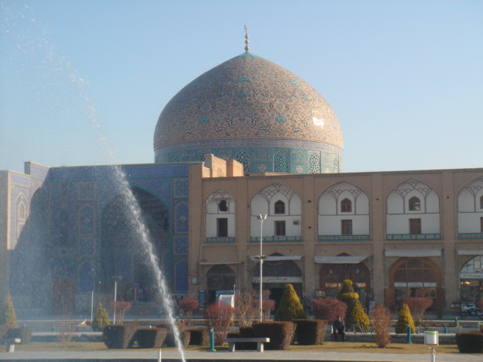
In Persepolis I was approached by two Engineering Ph.D. students who asked if they could practice their English with me as we walked through the ancient stone monuments… their greatest dream in life was to come to America! In the magnificent square of Esfahan I was asked to sit with a group of female architecture students who had come here to study the great mosque. They wanted to know all about life in the West! In Mashad, one of the holiest cities in the Middle East I spent time at the Shrine of Imam Reza, visited by millions of Shiite pilgrims from all over the world. As I sat watching thousands of devotees during prayers, I was joined by a man and his family who had come from Baghdad to pay homage. The family invited me to join them for lunch, we talked about life in present day Iraq and bid farewell to each other wishing for peace in his country. As I left the shrine, I complimented the traffic police man on his clean uniform…he asked where I was from. I told him America, he said his name was Ali, he gave me a big smile and a salute as my car drove off.

I had an interesting encounter in the Armenian Quarter of Esfhan with a few young Russians who were having lunch in the same restaurant. One of the group members was an interpreter who spoke impeccable English. The others in the group were young scientists all of whom were working on the nuclear plant in Southern Iran. Throughout the conversation between my Iranian guide, myself and a group of Russians I discovered yet again our common humanity. Putting politics aside, we talked about their families back in Russia, their mothers and fathers and their aspirations in life. All of them were hoping to make a better life for themselves and they all dreamed of visiting America one day!

Perhaps the most moving experience throughout the trip was an encounter I had with a young girl in Shiraz. She had walked up to me, curious about where I was from. In broken English she began to talk to me and asked me many questions about my religion and the people of America. She could not understand why I had come to Iran because she thought that Americans did not like Iranians and their country. In the end she said “I am Muslim and I ask you…please, when you go home, tell the people in America about us and tell them to come and meet the people of Iran”.

Cobb & Associates and Authentic Asia have prepared a journey to Iran in June 2010.

We will travel to Tehran, Shiraz, Esfahan, Mashad and the Caspian Sea and will offer an optional extension to Kerman and Yazd, home the Sufi and Zoroastrian religions.

The trip dates are June 23 to July 3, 2010. The per person trip cost of
$ 4,870 includes the following:

- international airfare on Lufthansa Airlines between New York and Tehran
- all accommodations in double occupancy
- full board throughout
- bottled water during sightseeing
- all flights within Iran
- all sightseeing with entrance fees
- service of an Iranian English speaking guide throughout
- service of ac-transportation
- all transfers

The single room supplement cost is $ 520.

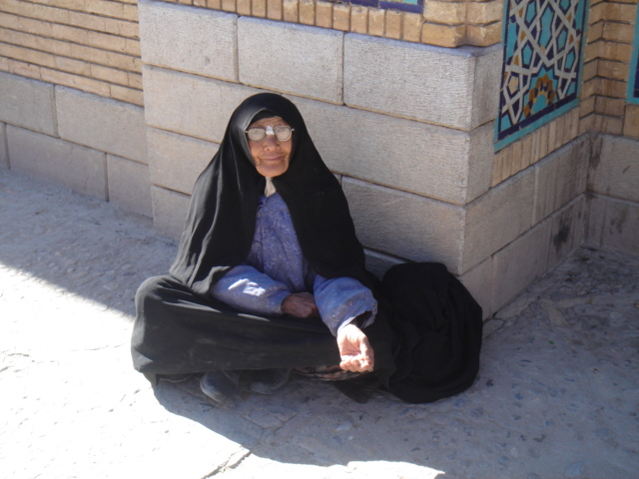
The visa for Iran will be obtained through Authentic Asia. We will need your full passport and employment details. This information will be sent to the Ministry of Tourism in Iran where a visa approval number will be issued. Once the number has been issued your passport and completed visa form will be sent to the Iranian Interest Section in Washington. Visa processing will take about 3 weeks from the time the approval number has been received.

For additional information, please call Tina Patterson at tel. 888-586-9958 or e-mail her at tina@authenticasia.net

